A

INDUSTRIAL TRAINING

PROJECT REPORT

ON

COMPUTER NETWORKING

In partial fulfillment for the award of the Degree of

**BACHELOR OF TECHNOLOGY**

**IN**

**COMPUTER SCIENCE ENGINEERING**

*Submitted by*

**DAKSH KUMAR SHARMA**

**Under the Guidance of**

**Mr. SAURABH GUPTA**



**DEPARTMENT OF COMPUTER SCIENCE ENGINEERING**

**SRM INSTITUTE OF SCIENCE AND TECHNOLOGY**

NH-24, MODINAGAR, (DELHI-NCR)

**CONTENTS**

|  |  |
| --- | --- |
| Serial no. | Topic |
| 1 | Abstract |
| 2 | Introduction to B.S.N.L |
| 3 | VOIP- Introduction and background |
| 4 | Project description |
| 5 | Significance of project |
| 6 | Conclusion |
| 7 | References |
| 8 | Daily diary |

**ABSTRACT**

This work presented the re-engineering of a university’s telephone system through the design of alternative implementation and a specification scenario for a campus-wide telephony system based on Voice over Internet Protocols (VoIP) technology; and demonstrates that the technology can be adapted for use in our university community to make cheaper calls using the desk Internet Protocol (IP) phone and data services. This research drew inspirations from similar efforts by some institutions to replace their old PSTN telephony system with the VoIP-based architecture. The Analysis phases of the Structured Systems Analysis and Design Methodology (SSADM) were adopted in carrying out a detailed study of the underlining technologies of VoIP and the possibilities of implementing a campus-wide telephony system using the technology; prototyping was deployed to build a prototype VoIP-based telephony system and Cisco Packet tracer was configured to run several simulation sessions of the developed specifications. The simulation results showed that VoIP can be successfully deployed to provide in a flexible manner, additional data-driven services in campus-wide telephony through a merger of telephone and information technology facilities.

**Keywords**- VOIP, Telephony, Prototyping, Cisco packet tracer (version 6.0), Design specification

**INTRODUCTION TO BSNL**



Particulars of Organisation

Incorporated on 15.9.2000, vide Registration No. 55-107739, dated the 15th September, 2000 and became entitled to commence business with effect from 19th September, 2000.

Date of incorporation:

Incorporated on 15.9.2000, vide Registration No. 55-107739, dated the 15th September, 2000 and became entitled to commence business with effect from 19th September, 2000.

The Company (BSNL) took over the .business of providing telecom services and network management throughout the country except the metro cities of Delhi and Mumbai of the erstwhile service providing departments of the Govt. of India, i.e., the Departments of Telecom Services and Telecom Operations w.e.f. 1.10.2000 pursuant to anMoU signed between the BSNL and the Govt. of India.

Type of Company

Government company under section 617 of the companies act, 1956

Administrative Ministry

Govt. of India, Ministry of Communication and Information Technology, Department of

Telecommunications.

Details of Disinvestments

The entire share capital of the Company is held by the Govt. of India.

Shareholding pattern

Government of India is holding 100% of the share capital of the Company.

Share Capital

AuthorisedCapital – Rs.17,500crores, divided into 1,000,00,00,000[One Thousand Crores] Equity Shares of Rs.10/- each; and 750,00,00,000 [Seven Hundred and Fifty Crores] Preference Shares of Rs.10/- each.

Objectives of the company

As set out in the objects clause of the Company’s Memorandum of Association.

ASPIRATIONS

Be the leading Telecom Service Provider in India with Global presence.

Create a customer focused organization with excellence in sales, marketing and customer care.

Leverage technology to provide affordable and innovative products / services across customer segments.

Provide a conductive work environment with strong focus on performance.

Establish efficient business processes enabled by I.T.

**PROFILE OF THE COMPANY’S BUSINESS**

A.GLIMPSES OF MAIN SERVICES OFFERED

1. BASIC AND LIMITED MOBILE TELEPHONE SERVICES

BSNL is the leading service provider in the country in the Basic Telephone Services. As on 31.03.2012 more than 22.46 million Direct Exchange Lines & more than 4.003 Million WLL Telephone Connections are existing. BSNL has provided a number of attractive tariff packages & Plans which shall further strengthen its subscriber base.

2. CELLULAR MOBILE TELEPHONE SERVICES

BSNL’s GSM Technology based Cellular Network reached a long way, covering 30,836 cities/towns with a subscriber base of over 9.450 crores as on 31st March 2012 out of which 9.108 crores cellular telephones are in pre-paid segment.

3. INTERNET SERVICES

BSNL offers Dialup Internet services to the customers by Post-paid service with the brand name ‘Netone’, and pre-paid service with the brand name ‘Sancharnet’. The post-paid service is a CLI based access service. Sancharnet is available on local call basis throughout India toISDN and PSTN subscribers. The Internet Dhaba scheme of the Company aims to further promote Internet usage in rural and semi urban areas.

To keep pace with the latest and varied value added services to its customers, BSNL uses IP/MPLS based core to offer world class IP VPN services. MPLS based VPNs is a very useful service for Corporate, as it reduces the cost involved as well as the complexity in setting up VPNs for customers networking. As on 31.07.2010, total Internet customer base was 37,58,791 and 3289 blocks were covered with Internet Dhabas.

4. Intelligent Network

BSNL Intelligent Network provides value added services to customers of fixed line and mobile. At present, BSNL offers Toll Free Phone (TFS), Premium Rate Service (PRM), India Telephone Card (ITC) now called Universal ITC, Account Card Calling (ACC), Virtual Private Network (VPN), Universal Access Number (UAN), tele-voting, Universal Personal Number and Prepaid Fixed line general and PCO (FLPP General and FLPP PCO) IN services. The Toll free Service (TFS) and Universal Access Number (UAN) are accessible from all Indian Telecom Operators. The Indian Telephone Card facility with per second pulse and new value added services are being provided throughout the country.

These value added services are provided from five number of new technology IN platforms (Four General purpose IN and One Mass Calling IN) at Ahmadabad, Bangalore, Kolkata, Lucknow& Hyderabad.

5. BROADBAND SERVICES

BSNL has launched its broadband services under brand name “BSNL BROADBAND” on 14-01-05. This offers High Speed Internet Access with speed ranging from 256 Kbps to 24 Mbps. Ever since its inception BSNL is continuously expanding its broadband network in response to ever growing demand of broadband service throughout India.

Present customer base is 76,86,033 with equipped capacity of 85,26,074. The services provided are

•High Speed Internet Connectivity.

•Band width on Demand (planned).

•Virtual Private Network (VPN) service over broadband.

•Dial VPN services to MPLS VPN customers.

•IPTV services.

•Games on Demand Service.

•VVoBB

•Entertainment portal.

B. DEVELOPMENT OF RURAL TELECOM NETWORK

1. Rural DELs :

As on 31.3.2012, in BSNL’s network, a total of 74,92,420 Rural Telephone Connections were working.

2. (a) Village Public Telephones (VPTs) & RCPs:-

BSNL, in its unstinted efforts to make the slogan ‘Connecting India’, a reality, had provided VPTs in 5,77,131 villages up to 31.3.2012 as per Census 2001.

The company entered into an agreement with USO Fund for expansion of rural telecom network for providing VPTs in 66,822 undisputed, undisturbed, accessible and inhabited villages having population more than 100 as per census 1991 in the country. The 4520 numbers of villages have already been dropped by USOF, DOT due to various reasons such as zero population, Naxalite/ Insurgent areas, Villages transferred to urban area, submerged etc. BSNL has provided VPTs in 62088 villages out of 62302 up to 31.3.2012.

BSNL has entered into an agreement with USOF, DOT in Feb. 2009 for provisioning of VPTs in 62,443 inhabited villages as per Census 2001. Out of these, BSNL has provided 49408 VPTs till 31.3.2012. The 3425 numbers of villages are covered by PBSO (Private Basic Service Operator)

There are plans to replace all MARR VPTs in the country. As of now, 1,84,785 MARR VPTs have been replaced in the country up to 31.3.2012.

All 21,958 RCPs allotted by USOF, DOT have been provided by BSNL in villages with population of more than 2,000.

2 (b). Public Telephones:-

There are more than 10,80,316 PCOs working in the BSNL Network out of which around 6,32,052 (including Highway) PCOs are having STD/ISD as on 31-03-2012. BSNL has 2905 Internet Dhabas as on 31-03-2012.

C.NETWORK MANAGEMENT

BSNL is committed to provide a robust state of the art infrastructure that will provide stable and superior services to its customers. Accordingly, the MLLN network covering more than 200 cities was made operational in May 2004. Since then, about 22000 circuits have been provided on this network. This has provided high level of stability to the leased circuits and capability to offer N X 64 Kbps circuits. Keeping in view the growing demand of leased circuits, the network is being expanded to cover about50 more locations and additional capacity at many existing locations is also being provided.

To improve the operational efficiency of CCS 7 signaling, stand-alone signaling transfer point (SSTP) equipment is being procured. This will also enable the Company to measure signaling traffic of other operators, who are using its signaling network for exchanging messages, especially with regard to cellular services. BSNL has more than 6.99 Lakhs Route Kilometers of optical fiber network in the country & has installed capacity more than 10.7 million lines for the TAX meant for the STD/ISD network.

D.Setting up KU Band VSAT network

BSNL has started KU Band VSAT services in 2006 with Hub at Bangalore. The KU Band VSAT of BSNL is meant to provide Data Service, Voice Video Conferencing, Telemedicine Service etc. in remote areas and in locations where landline service is non-feasible/fault prone. The VAST communication is predominantly data communication via satellite and smaller antennae 1.04/1.2m are deployed in the customer premises and they will be communicating to the customer centers through VSAT Hubs.

At present, three KU Band VSAT Hubs are functioning, Sikandrabad (Delhi) Hub, Mumbai Hub and Bangalore hub from where BSNL, provides its service to remote VAST sites. As on date about 11,400 VSATs including commercial customers of Banking sector, Public Sector undertakings, Govt. organizations are working from Sikandrabad Hub, Mumbai Hub and Bangalore Hub. Sikandrabad Hubs are functioning through UPSTAR Thaicom – 4 Satellite and entire country excluding Andaman Nicobar & Lakshadweep Islands are covered with 16 Spot Beams. Bangalore Hub is functioning through GSAT-8 Indian Satellite which also has whole India coverage including Andaman Nicobar & Lakshadweep Islands. Due to its fast deploy ability, the KU Band and VSAT service is also of rescue to BSNL in restoring emergency communication service.

Southern Telecom Projects, Bangalore is the nodal agency for provision of this KU Band VSAT service.

E. Policy on transmission network maintenance

BSNL have large transmission networks of Optical Fibers, Satellite, Digital M/W. To improve the maintenance of transmission network, guidelines for route parties and vehicles have been formalized. A computerized networkfor booking of transmission systems faults namely, SBNM (System Booking Network Management) system has already working with data server at Kolkata for booking the system faults by the Maintenance Regions and it is monitored by the Sr. GM (CNO) cell at BSNL Corporate Office, New Delhi.

One more computerized system for fault booking up to the minimum level of 64 KB / 2MB & above has been introduced, namely FMS (Fault Management System) of Regional Network Monitoring Centre (RNMC), developed & maintained by Southern Telecom Region. STR has already started the fault booking on this system. Other maintenance regions are also being implemented the model of RNMC of STR.

F.Annual Maintenance contracts for switching system & WLL

Comprehensive AMC, which includes hardware and software maintenance and upgrade, has been arranged with the respective equipment suppliers. BSNL is continuously trying to improve the performance of WLL network through AMC and preventive and corrective maintenance support. AMC arrangements have also been made with suppliers of FWTs and hand held terminals.

G. Fault Repair Services – Achievements at a glance (Basic Service)

|  |  |  |  |  |
| --- | --- | --- | --- | --- |
| **Sl.** | **Parameters** | |  | **Year** |
| **No.** |  |  | **2010-11** | **2011-12** |
|  |  |  | **Achievement** | **Achievement** |
| 1 | Fault rate/100 | | 4.73 | 4.69 |
|  | telephones/month (%) | |  |  |
|  |  | |  |  |
| 2 | **CCR** | |  |  |
|  | i) | Local | 67.22 | 67.4 |
|  | ii) | Junction | 56.84 | 62..84 |
|  | iii) | STD | 53.24 | 53.4 |
| 3 | **Fault clearance** | |  |  |
|  | i) | Same day | 80.65 | 75.39 |
|  | ii) | Next day | 89.36 | 87 |
|  | iii) Within 7 days | | 96.4 | 93.38 |
| 4 | **MTTR** | | 7.86 | 7.05 |

H.COMPUTERISATION

Operation & Business Support System and billing of Wire line & Broadband customers are being managed through 4 Zonal Data Centers. Call center facility is being extended to all Wire line & BB customers by dialing 1500 & 1504 respectively.

Online bill payment facility and other customer service to wire line & Broadband customers are available through corporate website www.bsnl.co.in.

BSNL also offering Co-location & Hosted Services through 9 Internet data Centers (IDCs) spread across the country.

I.BUSINESS DEVELOPMENT

Apart from BSNL Managed Enterprise Solutions, EB-I unit takes care of Total Solutions for Large Enterprise Customers. BSNL Managed Enterprise Solutions are in following areas:-

Existing Services:

1.Managed Network Service (MNS)

2.Global Managed Network Service (GMNS)

3.Managed Software as a solution (SaaS)

4.Managed Global conferencing.

5.ManagedTelepresence (Under Finalization)

6.Managed Digital Signage (Under Finalization)

7.Managed Unified Communication Services (Under Finalization)

Future Services:

1.Managed security solution

2.Managed web-based solution.

**VOIP- INTRODUCTION AND BACKGROUND**

The technology of Voice over Internet Protocol (VoIP) involves using the technology of the Internet Network to deliver voice communications and multimedia session as packets over the network. Because VoIP is a telephony service, it is also referred to as broadband phone service, internet telephony, IP telephony, and broadband telephony. Due to the affordances of Internet-ready phones, and the fact that the IP is the communication protocol of most devices, VoIP is best positioned to be the service platform for next-generation application. The Public Switched Transfer Network (PSTN) on the other hand is a connection-oriented, circuit-switched network that uses dedicated channels for transmission. The PSTN had switched to transmitting digital signals to solve the problems associated with its original analog transmission using Pulse Code Modulation (PCM) to convert all analog signals into digital transmissions at the calling and receiving ends. However, the PSTN suffers two significant disadvantages: high cost resulting from the expensive bandwidth and an inefficient use of networking channels. VoIP unlike its predecessor, the PSTN which is currently built on a closed infrastructure; is built on an open infrastructure and several vendors can provide applications and access. While the PSTN technology involves vendors only building applications specific for their equipment and its current architecture has not made it possible for many vendors to write new applications for it; VoIP allows the development of more creative solutions and applications as well as the convergence of data, voice and video in one channel.

This research is aimed at simulating a VoIP-based telephony service using a university communication system. We believe that if we can successfully implement the simulation, and given the advantages of VoIP over the traditional PSTN technology, a modern telephony system can be implemented for the campus. The researchers aimed at reducing cable clusters around offices, facilitating in-office communication and enabling conference calling at any point where the IP phone or VoIP phone is being installed. The project covered the interconnection of different offices and the researchers, with the help of simulation showed that it was possible to make cheaper calls using the desk IP phone and video streaming on the Soft Phones and interfaces installed on Personal Computers (PC).

**PROJECT DESCRIPTION**

Components Used:

There are 3 computers, 3 IP phones, 1 Router (2811 series), 1 Switch (2960-24TT series) used in the project.

The Router is connected to the Switch through straight wire which is then connected to the 3 IP phones which are further connected through straight wire to the 3 Computers.

**Project Interface**

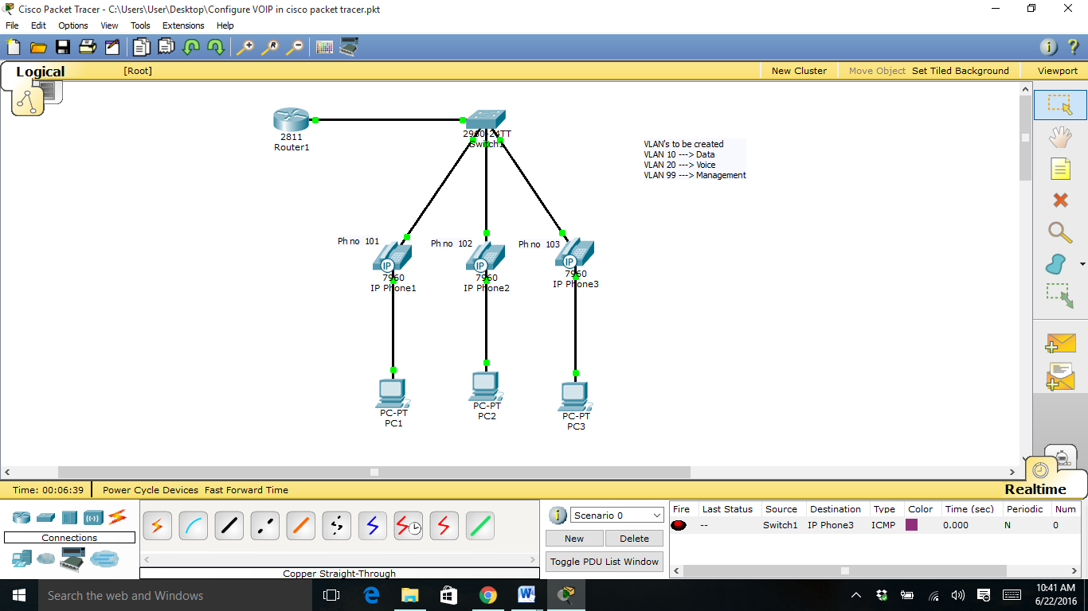

For Switch 1:

Switch>en

Switch#conf t

Enter configuration commands, one per line. End with CNTL/Z.

Switch(config)#vlan 10

Switch(config-vlan)#name Data

Switch(config-vlan)#vlan 20/

Switch(config-vlan)#name Voice

Switch(config-vlan)#vlan 99

Switch(config-vlan)#name Management

Switch(config-vlan)#exit

Switch(config)#intvlan 99

Switch(config-if)#

Switch(config-if)#ip add 192.168.99.10 255.255.255.0

Switch(config-if)#no shut

Switch(config-if)#do wr

Building configuration...

[OK]

Switch(config-if)#exit

Switch(config)#ip default-gateway 192.168.99.1

Switch(config)#int fa0/1

Switch(config-if)#switchport trunk native vlan 99

Switch(config-if)#exit

Now connecting the IP phones

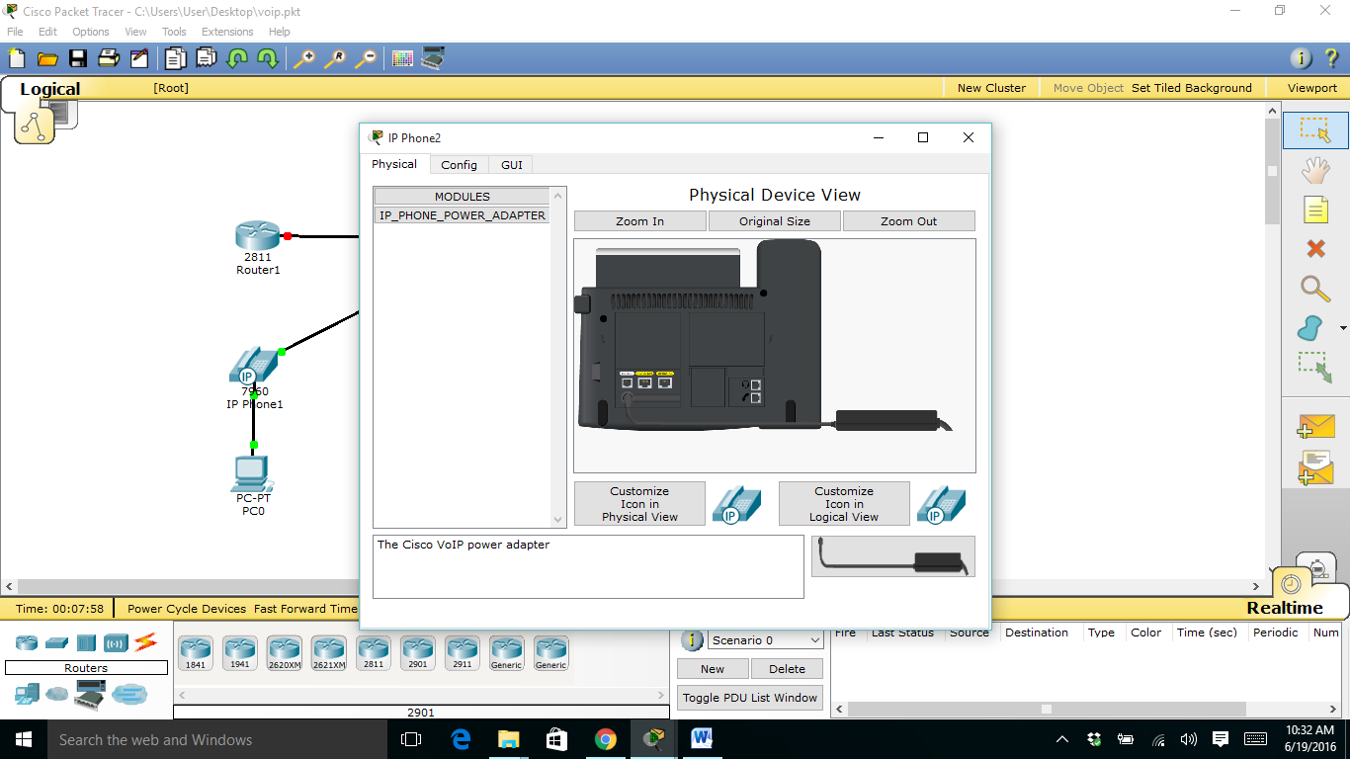

Switch(config)#int range fa0/2-4

Switch(config-if-range)#switchport access vlan 10

Switch(config-if-range)#switchport voice vlan 20

Switch(config-if-range)#no shut

Switch(config-if-range)#exit

For Router 1:

Router>en

Router#conf t

Enter configuration commands, one per line. End with CNTL/Z.

Router(config)#int fa0/0

Router(config-if)#no shut

Router(config-if)#int fa0/0.10

Router(config-subif)#encapsulation dot1Q 10

Router(config-subif)#ip add 192.168.10.1 255.255.255.0

Router(config-subif)#no shut

Router(config-subif)#exit

Router(config)#int fa0/0.20

Router(config-subif)#encapsulation dot1Q 20

Router(config-subif)#ip add 192.168.20.1 255.255.255.0

Router(config-subif)#no shut

Router(config-subif)#exit

Router(config)#int fa0/0.99

Router(config-subif)#encapsulation dot1Q 99 native

Router(config-subif)#ip add 192.168.99.1 255.255.255.0

Router(config-subif)#exit

Router(config)#ipdhcp excluded-address 192.168.10.1 192.168.10.9

Router(config)#ipdhcp excluded-address 192.168.20.1 192.168.20.9

Router(config)#ipdhcp pool Data

Router(dhcp-config)#network 192.168.10.0 255.255.255.0

Router(dhcp-config)#default-router 192.168.10.1

Router(dhcp-config)#exit

Router(config)#ipdhcp pool Voice

Router(dhcp-config)#network 192.168.20.0 255.255.255.0

Router(dhcp-config)#default-router 192.168.20.1

Router(dhcp-config)#option 150 ip 192.168.20.1

Router(dhcp-config)#exit

#configuring the IP phones

Router(config)#telephony

Router(config)#telephony-service

Router(config-telephony)#max-dn 3

Router(config-telephony)#max-ephones 3

Router(config-telephony)#ip source-address 192.168.20.1 port 2000

Router(config-telephony)#exit

Router(config)#ephone-dn 1

Router(config-ephone-dn)#number 101

Router(config-ephone-dn)#exit

Router(config)#ephone-dn 2

Router(config-ephone-dn)#number 102

Router(config-ephone-dn)#exit

Router(config)#ephone-dn 3

Router(config-ephone-dn)#number 103

Router(config-ephone-dn)#exit

Router(config)#ephone 1

Router(config-ephone)#type 7960

Router(config-ephone)#button 1:1

Router(config-ephone)#ephone 2

Router(config-ephone)#type 7960

Router(config-ephone)#button 1:2

Router(config-ephone)#ephone 3

Router(config-ephone)#type 7960

Router(config-ephone)#button 1:3

Router(config-ephone)#exit

**Project Output:**

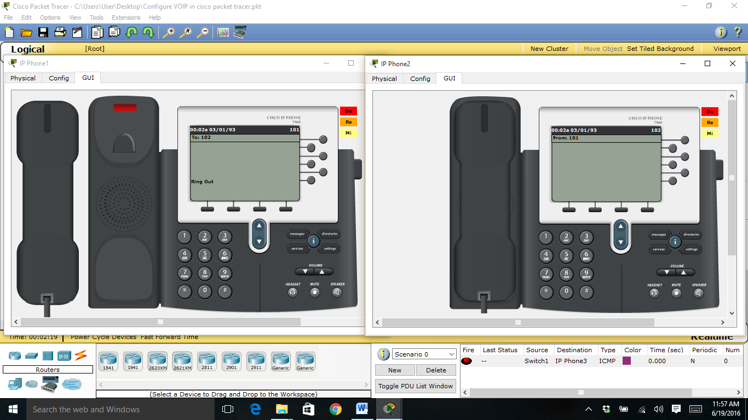

**Significance of Project:**

The project simply points out the working of a Voice over IP phone (VoIP) and how it is configured to be used in a real time business organization.

VoIP is important because, for the first time in more than 100 years, there is an opportunity to bring about significant change in the way that people communicate. In addition to being able to use the telephones we have today to communicate in real-time, we also have the possibility of using pure IP-based phones, including desktop and wireless phones. We also have the ability to use videophones, much like those seen in science fiction movies. Rather than calling home to talk to the family, a person can call home to see the family.

One of the more interesting aspects of VoIP is that we also have the ability to integrate a stand-alone telephone or videophone with the personal computer. One can use a computer entirely for voice and video communications (softphones), use a telephone for voice and the computer for video, or can simply use the computer in conjunction with a separate voice/video phone to provide data conferencing functions, like application sharing, electronic whiteboarding, and text chat.

VoIP allows something else: the ability to use a single high-speed Internet connection for all voice, video, and data communications. This idea is commonly referred to as convergence and is one of the primary drivers for corporate interest in the technology. The benefit of convergence should be fairly obvious: by using a single data network for all communications, it is possible to reduce the overall maintenance and deployment costs. The benefit for both home and corporate customers is that they now have the opportunity to choose from a much larger selection of service providers to provide voice and video communication services. Since the VoIP service provider can be located virtually anywhere in the world, a person with Internet access is no longer geographically restricted in their selection of service providers and is certainly not bound to their Internet access provider.

In short, VoIP enables people to communicate in more ways and with more choices. Hence the project has been made to bring about the widespread scope of the VoIP.

**Conclusion**

The researchers in this work had examined the underlining technologies of Voice over Internet Protocols (VoIP) and the possibilities of implementing a campus-wide telephony system using the technology. A prototype design was specified and a simulation was ran using the Cisco Packet Tracer to demonstrate that VoIP can be successfully deployed to provide in a flexible manner, additional data-driven services in campus-wide telephony through a merger of telephone and information technology facilities. While this work had demonstrated the feasibility of leveraging on the affordances of IP-enabled telephones and developing a VOIP-based campus-wide telephony, further research is recommended to test for voice quality and network performance as well as ability for network capacity planning when the system is fully implemented.

**References**

[1] Kumar, A. (2006), AnOverview of Voice over Internet Protocol (VoIP). Rivier college online academic journal 2(1).

[2] Pan, Y., Chung, J., Zhang, Z. (2012), Analysis of Performance of VoIP Over various scenarios OPNET 14.0. Group 11 Final Report on ENSC 427 Communication Networks, Simon Fraser University Spring 2012 http://www.sfu.ca/~ypa11/Ensc%20427/427.html.

[3] Kaul, A. (2012), IP Telephony: Review and Implementation. M.Sc. thesis, Department of Electrical Engineering and Computer Science and the Faculty of the Graduate School of the University of Kansas, USA.

[4] Dilekci, D., Wang, C., FengXu, J. (2013), The Analysis and Simulation of VoIP Group 3 Final Project Report on ENSC 427 Communication Networks, Simon Fraser University. Spring 2013 http://www.sfu.ca/~cjw11/427Project.html.

[5] Aguiño, G. I., (2007), Performance of VoIP strategies for hybrid Mobile Ad Hoc Networks. Masters thesis, Department of Computer Science, Karlstad University.

[6] Rabassa, A. H. (2010), Simulation Platform for the Planning and Design of Networks Carrying VoIP Traffic Masters of Applied Science in Electrical Engineering Thesis, Faculty of Graduate Studies and Research, Department of Systems and Computer Engineering, Ottawa-Carleton Institute for Electrical and Computer Engineering, Carleton University, Ottawa, Canada.

DAILY DAIRY

WEEK 1: get started with basics of networking and communication

WEEK 2: get hands on routing algorithms and broadband services

WEEK 3: start designing some basic network structure

WEEK 4: start a project as an assignment VOICE OVER IP